Loaded 212 epochs. Each epoch shape: (28, 92000)

Saved split 1/10 with 22 samples to 'equal_splits'.

Saved split 2/10 with 22 samples to 'equal_splits'.

Saved split 3/10 with 21 samples to 'equal_splits'.

Saved split 4/10 with 21 samples to 'equal_splits'.

Saved split 5/10 with 21 samples to 'equal_splits'.

Saved split 6/10 with 21 samples to 'equal_splits'.

Saved split 7/10 with 21 samples to 'equal_splits'.

Saved split 8/10 with 21 samples to 'equal_splits'.

Saved split 9/10 with 21 samples to 'equal_splits'.

Saved split 10/10 with 21 samples to 'equal_splits'.

Fold 1/10 Test Accuracy: 1.0000

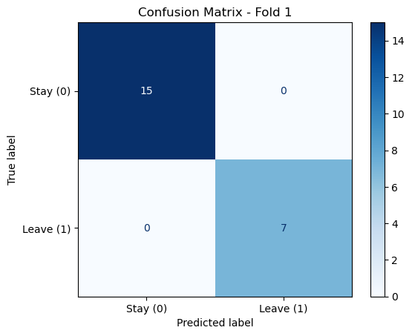

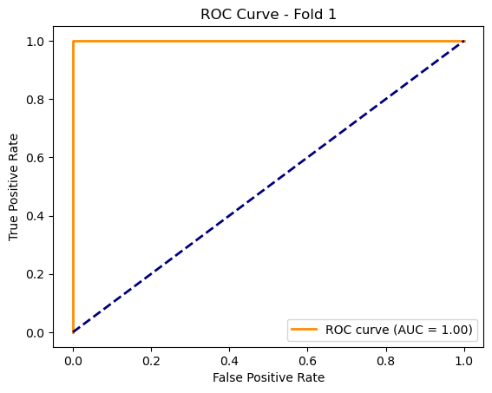

Fold 2/10 Test Accuracy: 0.5455

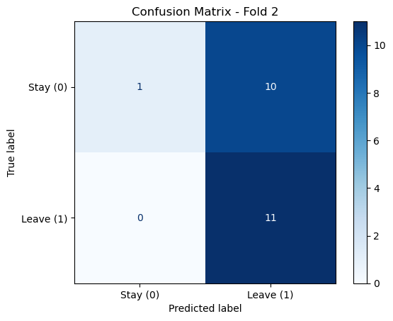

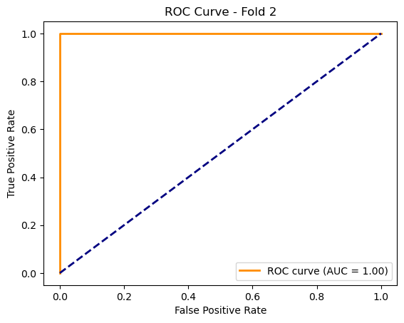

Fold 3/10 Test Accuracy: 0.5238

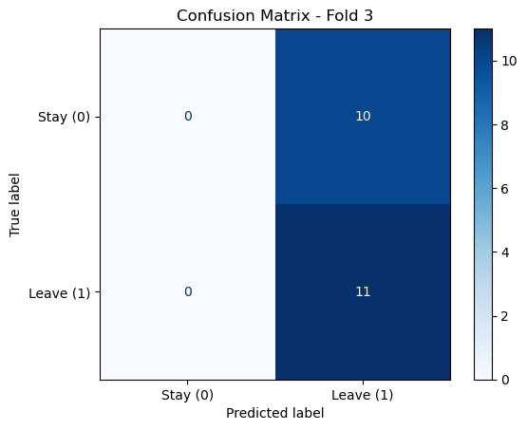

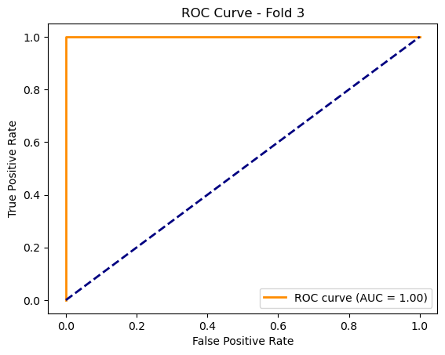

Fold 4/10 Test Accuracy: 0.5714

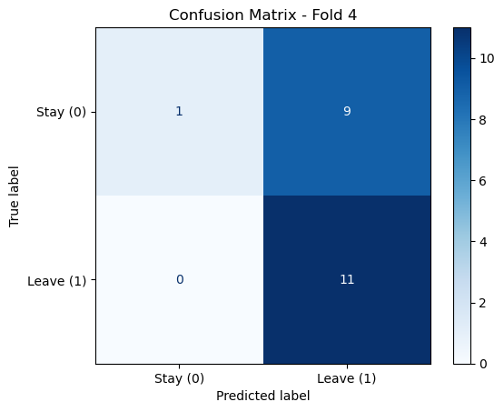

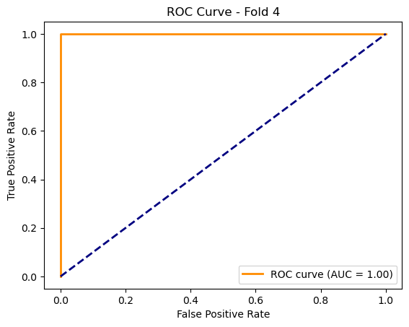

Fold 5/10 Test Accuracy: 0.5714

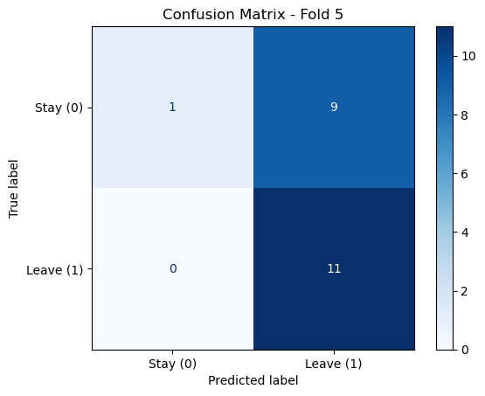

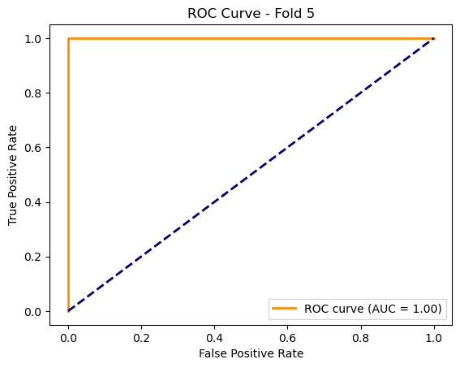

Fold 6/10 Test Accuracy: 0.7143

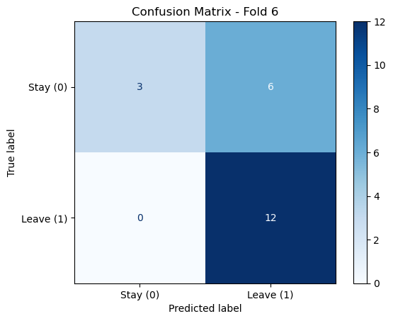

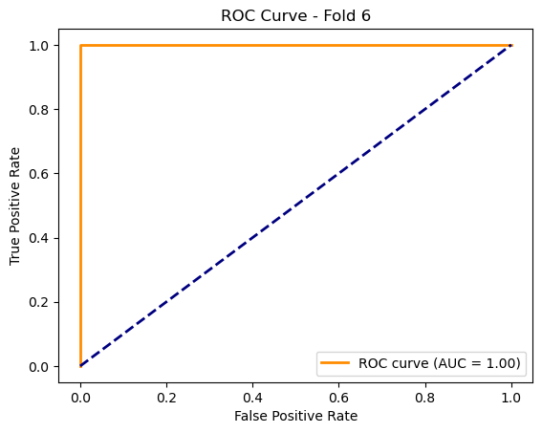

Fold 7/10 Test Accuracy: 0.6190

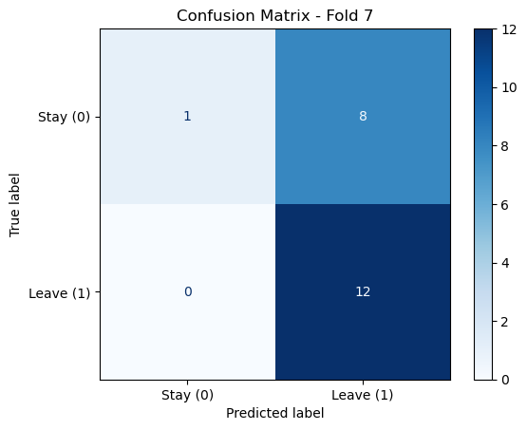

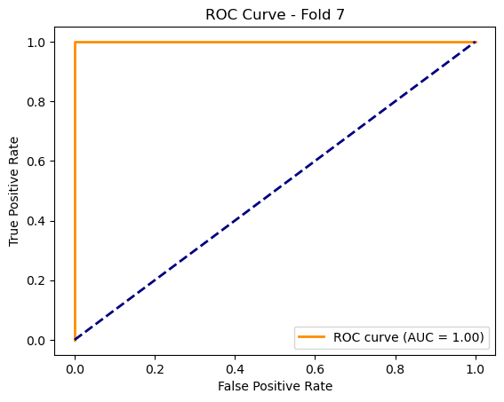

Fold 8/10 Test Accuracy: 0.4286

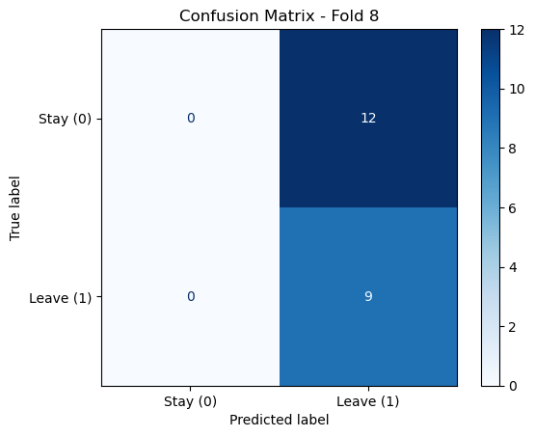

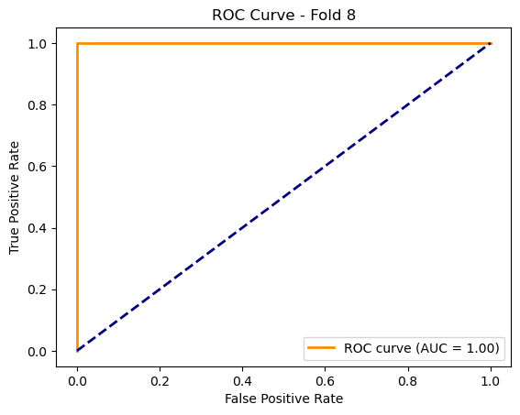

Fold 9/10 Test Accuracy: 0.5238

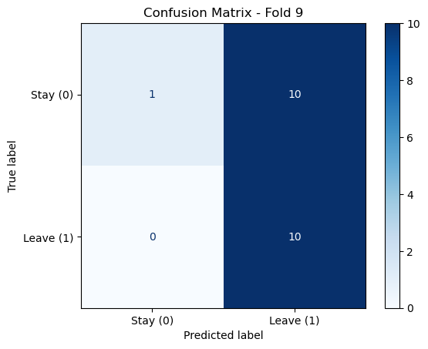

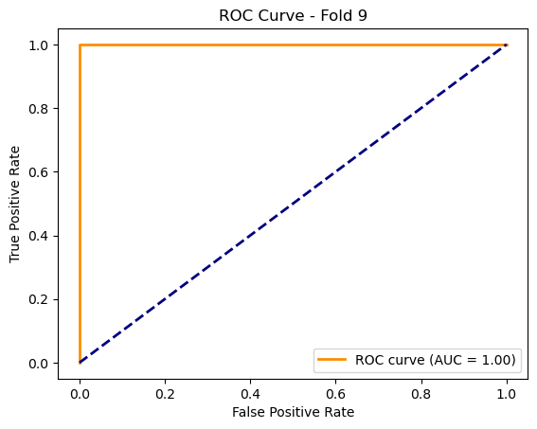

Fold 10/10 Test Accuracy: 0.5714

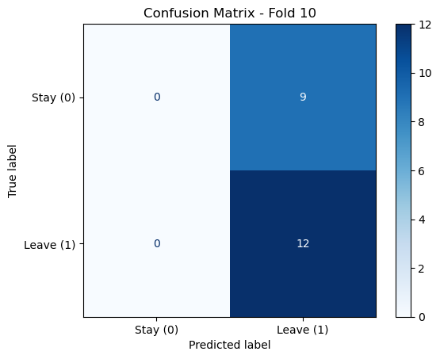

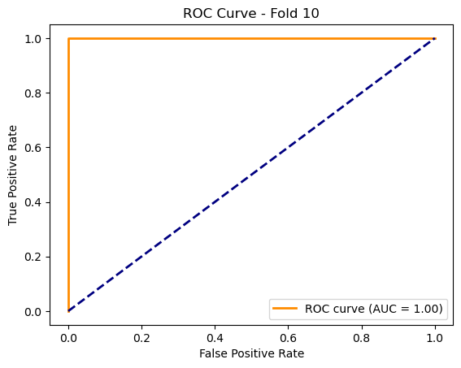

Average Test Accuracy across all folds: 0.6069